**A. Descriptive Questions:**   
  
**Can we nest the Scaffold widget? Why or Why not?**Answer: We can nest the scaffold widget but we should use one scaffold in one page because of routing.

**What are the different ways we can create a custom widget ?**Answer: we can create custom widget by so many ways   
1. Stateless widget   
2. Stateful widget   
3. Customer Painter  
4. MethodChannel (Incoming intents)

**How can I access platform(iOS or Android) specific code from Flutter?**Answer: We can access platform specific code via MethodChannel and EventChannel(Streaming)

**What is BuildContext? What is its importance?**   
Answer: BuildContext is a locator that is used to track each widget in a tree and locate them and their position in the tree. The BuildContext of each widget is passed to their build method. Remember that the build method returns the widget tree a widget renders. Each BuildContext is unique to a widget.

**B. Coding Questions:**

**1.** **Refactor the code below so that the children will wrap to the next line when the display width is small for them to fit.**

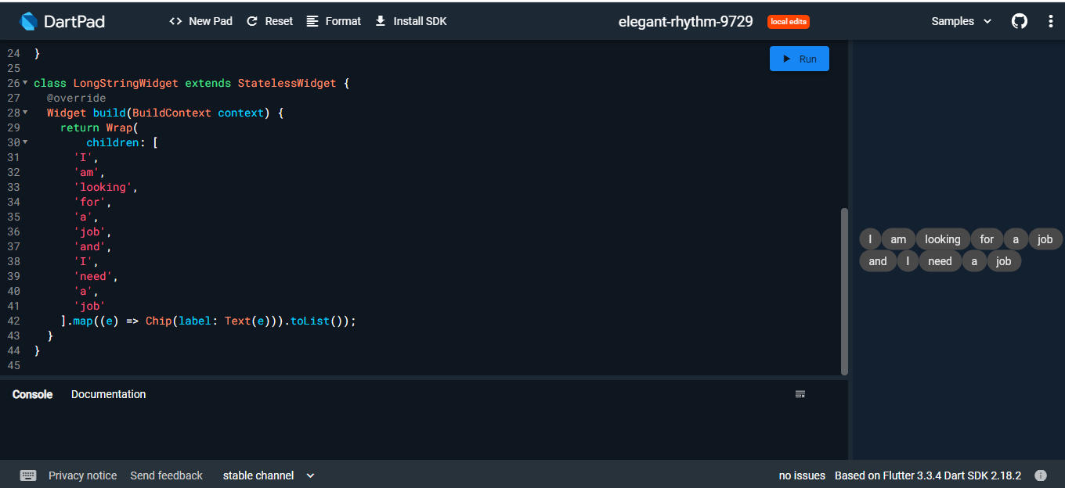

**2. Identify the problem in the following code block and correct it.**

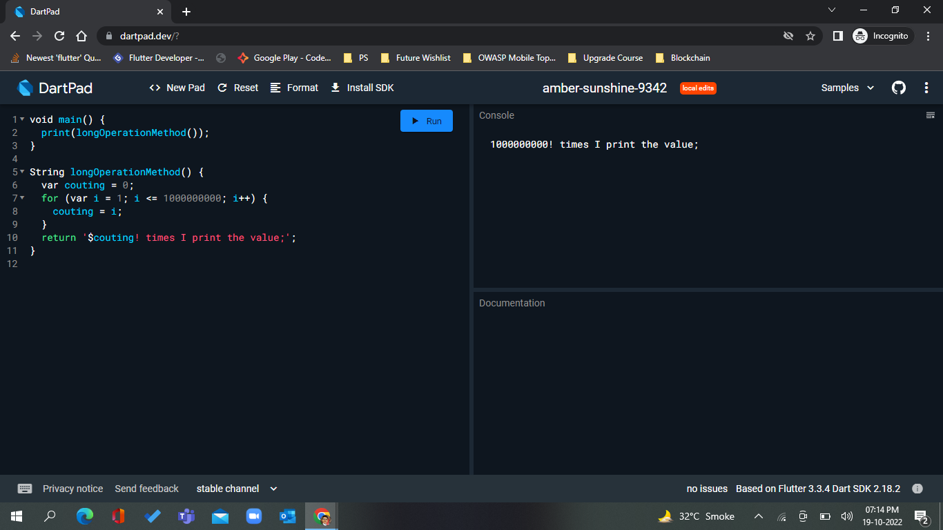

**3.In the below code, list1 declared with var, list2 with final and list3 with const. What is the difference between these lists? Will the last two lines compile?** // with var we can repeatedly initiated list1

var list1 = ['I','Love','Flutter'];

// Here we have pass reference of list1 to list2

// we can't not reinitiated list2 cause it's final

// we can manipulate list2 and when we do so then it will also

// populate in list1 cause list2 have reference of list1

// If we check hashcode of list1 and list2 then it will be same because of same address.

final list2 = list1;

// It will change index 2 with dart instead of Flutter

list2[2] = 'dart';

// Below line will not complie cause

// const variables must be initialized with a constant value.

const list3 = list1;  
